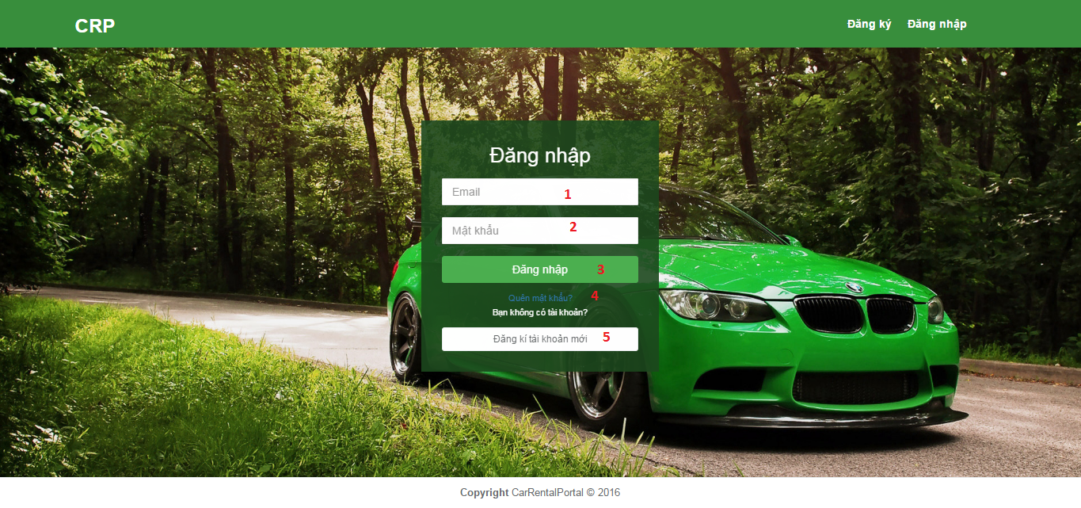

**Fields**

|  |  |  |  |  |  |  |
| --- | --- | --- | --- | --- | --- | --- |
| No | Field Name | Description | Read Only | Mandatory | Control Type | Data Type |
| 1 | email | Field for input user’s email | No | No | Textbox | String |
| 2 | Password | Field for input password | No | No | Textbox | String |

**Buttons/Hyperlinks**

|  |  |  |  |  |
| --- | --- | --- | --- | --- |
| No | Function | Description | Validation | Outcome |
| 3 | logIn | User login to the site | Email and Password must be correct | Homepage |
| 4 | forgetPassword | Go to recover password page when user forgot password | N/A | Recover password page |
| 3 | createNewAccount | User sign up for new account | N/A | Go to register page |

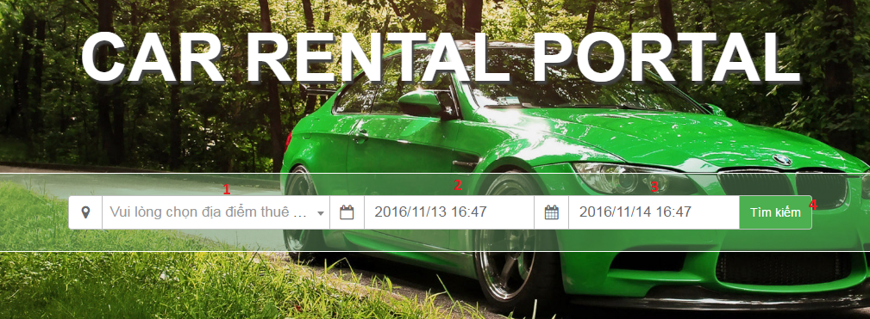

**Fields**

|  |  |  |  |  |  |  |
| --- | --- | --- | --- | --- | --- | --- |
| No | Field Name | Description | Read Only | Mandatory | Control Type | Data Type |
| 1 | location | Choose rent location | Yes | No | Dropdownlist | String |
| 2 | startTime | Choose start rent time | Yes | No | DateTimePicker | String |
| 3 | endTime | Choose end rent time | Yes | No | DateTimePicker | String |

**Buttons/Hyperlinks**

|  |  |  |  |  |
| --- | --- | --- | --- | --- |
| No | Function | Description | Validation | Outcome |
| 4 | search | Search vehicle | N/A | Advance search page |

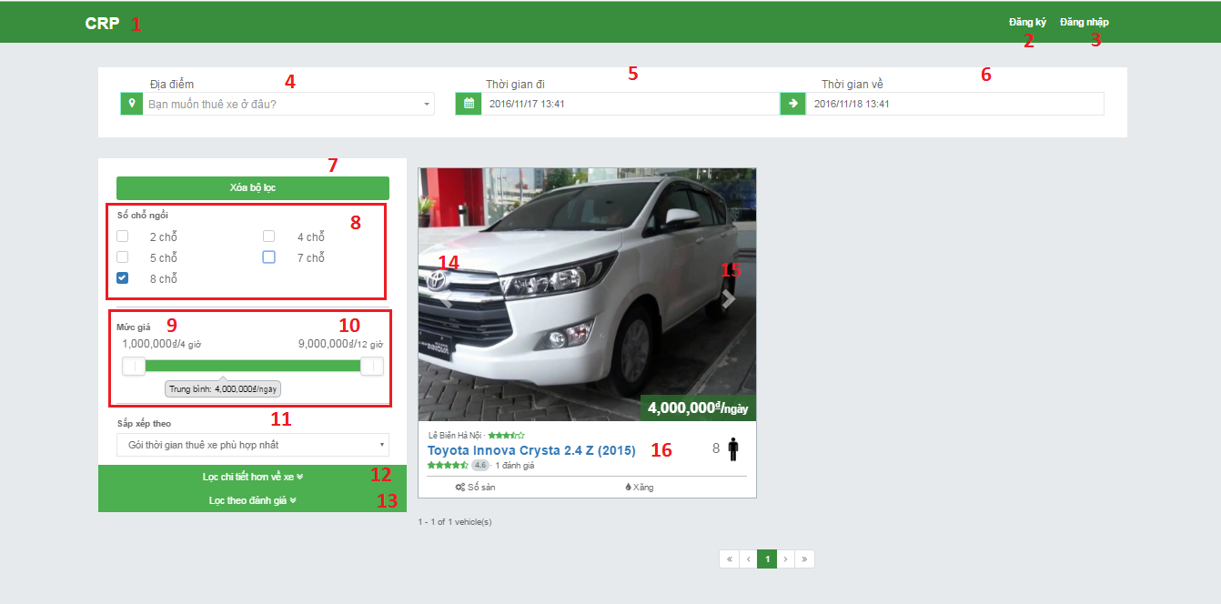

**Fields**

|  |  |  |  |  |  |  |
| --- | --- | --- | --- | --- | --- | --- |
| No | Field Name | Description | Read Only | Mandatory | Control Type | Data Type |
| 4 | location | Choose rent location | Yes | No | Dropdownlist | String |
| 5 | startTime | Choose start rent time | Yes | No | DateTimePicker | String |
| 6 | endTime | Choose end rent time | Yes | No | DateTimePicker | String |
| 8 | Seats | Choose how many seats for wanted vehicle | Yes | No | Combobox | String |
| 9 | leftSlider | Pull to higher the min price for search | Yes | No | Slider | String |
| 10 | rightSlider | Pull to lower the max price for search | Yes | No | Slider | String |
| 11 | Sort | Choose ways to show result | Yes | No | Dropdownlist | String |

**Buttons/Hyperlinks**

|  |  |  |  |  |
| --- | --- | --- | --- | --- |
| No | Function | Description | Validation | Outcome |
| 1 | logoButton | Clicks to go to homepage | N/A | Homepage |
| 2 | signUp | Clicks to sign up | N/A | Register page |
| 3 | logIn | Clicks to login | N/A | Login page |
| 7 | resetFilters | Clicks to reset filters | N/A | Clear all input user did |
| 12 | additionFilter | Clicks to show more addition search | N/A | Show search by brand, year, transaction type, fuel type, vehicle type, color |
| 13 | ratingFilter | Clicks to show search by rating of vehicle and garage | N/A | Show search by rating of vehicle and garage |
| 14 | leftArrow | Clicks to show image on the left side | N/A | Show image on the left side |
| 15 | rightArrow | Clicks to show image on the right side | N/A | Show image on the right side |
| 16 | vehicleName | Clicks to show vehicle information and booking | N/A | Show vehicle info page |

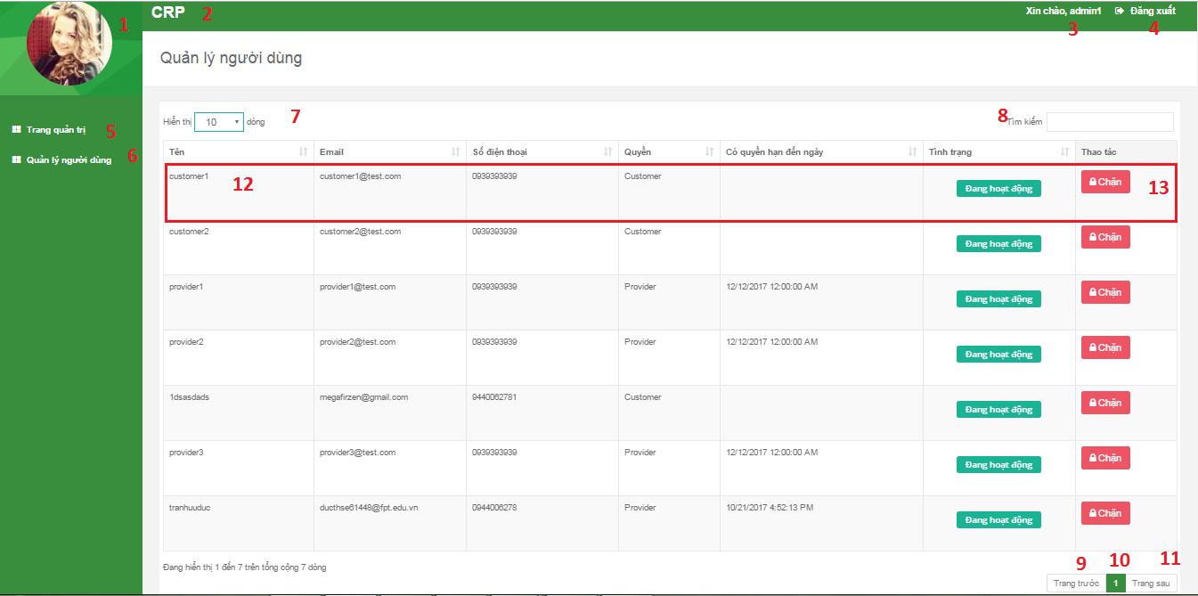

**Fields**

|  |  |  |  |  |  |  |
| --- | --- | --- | --- | --- | --- | --- |
| No | Field Name | Description | Read Only | Mandatory | Control Type | Data Type |
| 7 | showHowManyRecordPerPage | Cointain display options for how many records | Yes | No | Dropdown | String |
| 8 | searchValue | Search data from table | No | No | TextBox | String |
| 12 | specificRecordContent | Contain all fields of specific record | Yes | No | TextBox | String |
| 10 | curentPageOfTable | Current page of table | Yes | No | TextBox | String |

**Buttons/Hyperlinks**

|  |  |  |  |  |
| --- | --- | --- | --- | --- |
| No | Function | Description | Validation | Outcome |
| 1 | linkToUserDetailInformation | Redirect to user detail information page | N/A | Show user detail information page |
| 2 | linkToHomepage | Redirect to homepage | N/A | Show homepage |
| 3 | linkToDashboard | Redirect to dashboard page | N/A | Show dashboard page |
| 4 | logOut | Logout from system | N/A | Show homepage with guest role |
| 5 | linkToDashboard | Redirect to dashboard page | N/A | Show dashboard page |
| 6 | linkToUserManagement | Redirect to user management page | N/A | Show user management page |
| 13 | showDeactiveUserConfirm | Show deactive user confirm | N/A | Show deactive user confirm |
| 9 | showPreviousRecordOfTable | Show previous record of table | N/A | Show previous record of table |
| 11 | showNextRecordOfTable | Show next record of table | N/A | Show next record of table |

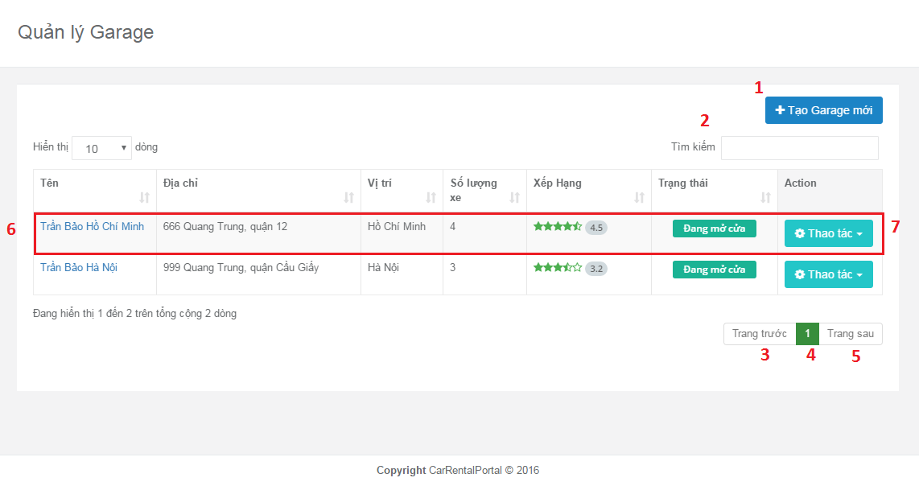

**Buttons/Hyperlinks**

|  |  |  |  |  |
| --- | --- | --- | --- | --- |
| No | Function | Description | Validation | Outcome |
| 1 | showCreateNewGarage | Show create new garage | N/A | Show create new garage popup |
| 7 | showOptionUserCanDoToGarage | Show options for user choose: detail information, open/close garage, delete | N/A | Show options for user choose: detail information, open/close garage, delete |
| 3 | showPreviousRecordOfTable | Show previous record of table | N/A | Show previous record of table |
| 5 | showNextRecordOfTable | Show next record of table | N/A | Show next record of table |

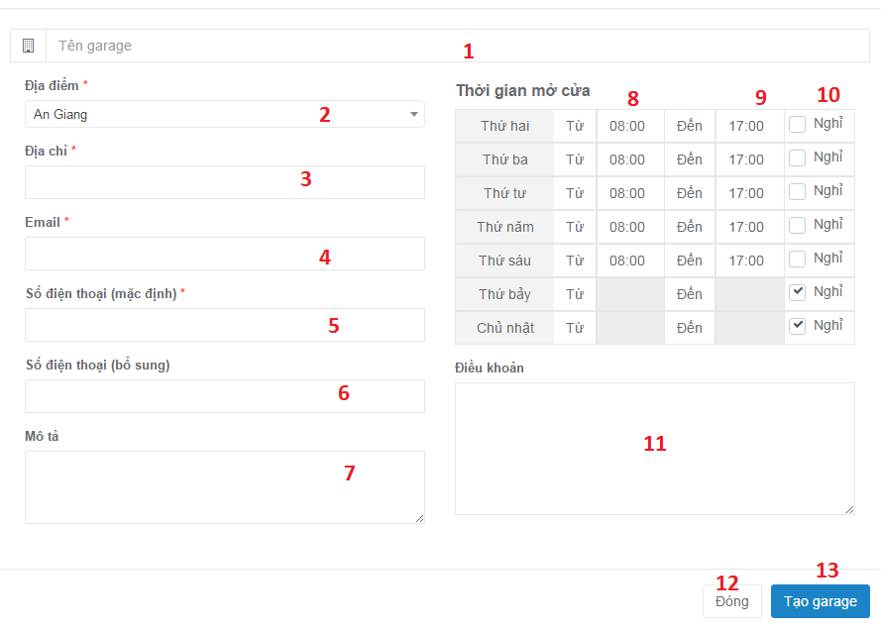

**Fields**

|  |  |  |  |  |  |  |
| --- | --- | --- | --- | --- | --- | --- |
| No | Field Name | Description | Read Only | Mandatory | Control Type | Data Type |
| 1 | garageName | Field for input garage name | No | No | Textbox | String |
| 2 |  | Search data from table | Yes | No | Dropdownlist | String |
| 3 | address | Field for input garage address | No | No | Textbox | String |
| 4 | email | Field for input garage email | No | No | Textbox | String |
| 5 | phoneNumberMain | Field for input main phone number | No | No | Textbox | String |
| 6 | phoneNumberSub | Field for input sub phone number | No | No | Textbox | String |
| 7 | detailInformation | Filed for input detail information | No | No | Textbox | String |
| 8 | openTime | Field for input open time | No | No | Textbox | Integer |
| 9 | closeTime | Field for input close time | No | No | Textbox | Integer |
| 11 | policy | Field for input policy of garage | No | No | Textbox | String |

**Buttons/Hyperlinks**

|  |  |  |  |  |
| --- | --- | --- | --- | --- |
| No | Function | Description | Validation | Outcome |
| 10 | indicateDayOff | Indicate day off | N/A |  |
| 12 | cancel | Cancel | N/A | Garage management page |
| 3 | createGarage | Save information to database | Validate all require field | Create success |

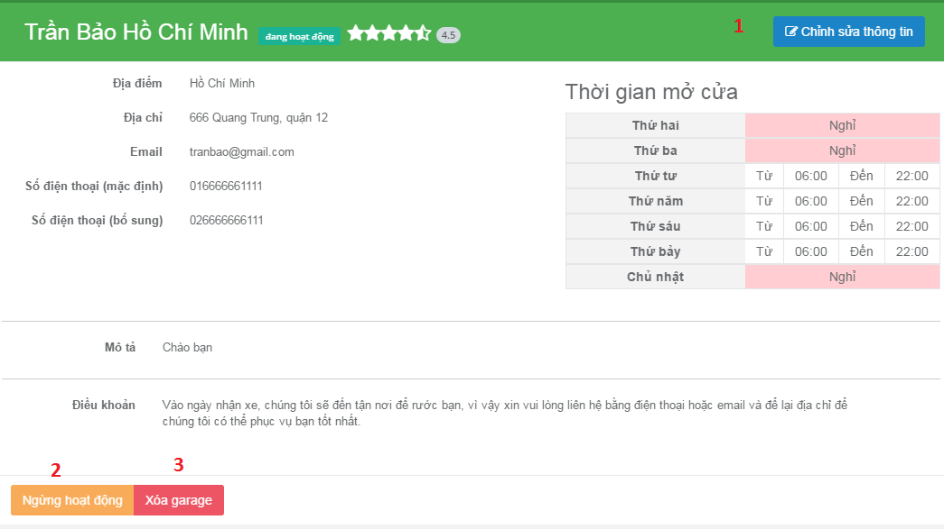

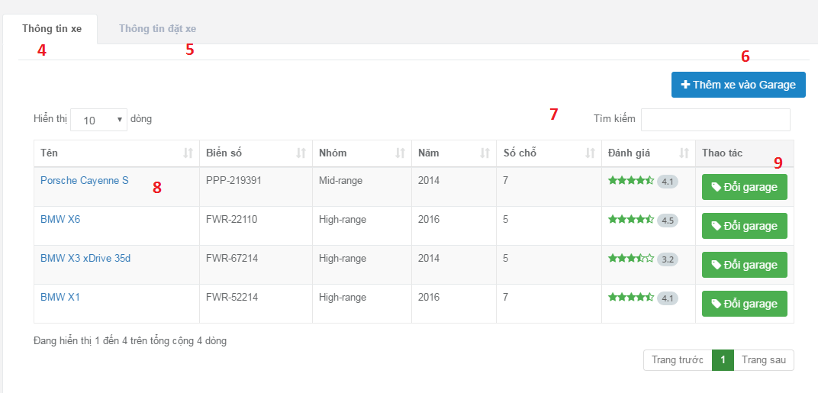

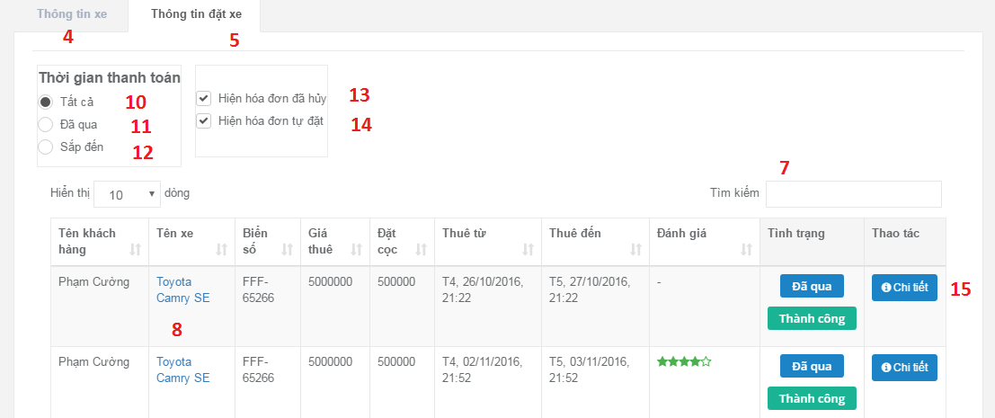

**Fields**

|  |  |  |  |  |  |  |
| --- | --- | --- | --- | --- | --- | --- |
| No | Field Name | Description | Read Only | Mandatory | Control Type | Data Type |
| 4 | garageName | Field for input garage name | No | No | Textbox | String |
| 7 | searchData | Search data from table | Yes | No | Textbox | String |
| 10 | allRadio | Checks to choose all time | Yes | No | Radio | String |
| 11 | passRadio | Checks to choose pass time | Yes | No | Radio | String |
| 12 | incomeRadio | Checks to choose in coming | Yes | No | Radio | String |
| 13 | cancelReceipt | Checks to choose cancel receipt | Yes | No | Combobox | String |
| 14 | selfBookReceipt | Checks to choose self-booking receipt | Yes | No | Combobox | String |

**Buttons/Hyperlinks**

|  |  |  |  |  |
| --- | --- | --- | --- | --- |
| No | Function | Description | Validation | Outcome |
| 1 | editGarageInformation | Edit garage information | N/A | Show field for edit |
| 2 | Active/deactiveGarage | Active or deactive garage | N/A | Garage become deactive/active |
| 3 | deleteGarage | Delete garage | N/A | Delete confirm |
| 4 | vehicleInfoTab | Clicks to show vehicle information tab | N/A | Show vehicle information tab |
| 5 | bookingInfoTab | Clicks to show booking information tab | N/A | Show booking information tab |
| 6 | addVehicleToGarage | Add vehicle to this garage | N/A | Show add vehicle confirm popup |
| 8 | linkToVehicleDetail | Clicks to go to that vehicle detail page | N/A | Go to vehicle detail page |
| 9 | changeGarage | Clicks to transfer the vehicle to another garage | N/A | Show change garage confirm popup |
| 15 | detailButton | Clicks to show detail information | N/A | Show detail information |

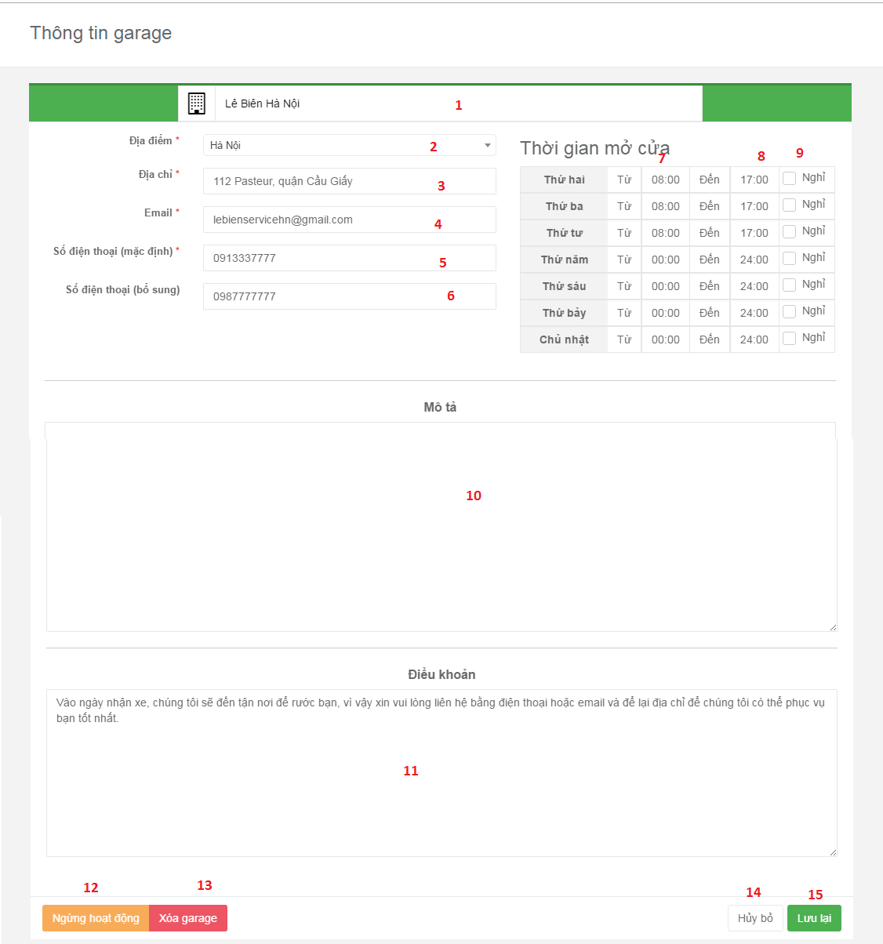

**Fields**

|  |  |  |  |  |  |  |
| --- | --- | --- | --- | --- | --- | --- |
| No | Field Name | Description | Read Only | Mandatory | Control Type | Data Type |
| 1 | garageName | Field for input garage name | No | No | Textbox | String |
| 2 | Location | Field for input location | No | No | Textbox | String |
| 3 | address | Field for input garage address | No | No | Textbox | String |
| 4 | email | Field for input garage email | No | No | Textbox | String |
| 5 | phoneNumberMain | Field for input main phone number | No | No | Textbox | String |
| 6 | phoneNumberSub | Field for input sub phone number | No | No | Textbox | String |
| 10 | detailInformation | Filed for input detail information | No | No | Textbox | String |
| 7 | openTime | Field for input open time | No | No | Textbox | Integer |
| 8 | closeTime | Field for input close time | No | No | Textbox | Integer |
| 9 | dayOff | Choose day off day | Yes | No | Combobox | String |
| 11 | policy | Field for input policy of garage | No | No | Textbox | String |

**Buttons/Hyperlinks**

|  |  |  |  |  |
| --- | --- | --- | --- | --- |
| No | Function | Description | Validation | Outcome |
| 12 | Active/deactiveGarage | Active or deactive garage | N/A | Garage become deactive/active |
| 13 | deleteGarage | Delete garage | Must be no vehicle in that garage | Delete confirm |
| 6 | addVehicleToGarage | Add vehicle to this garage | N/A | Show add vehicle confirm popup |
| 14 | cancelButton | Clicks to cancel | N/A | Go to garage detail page |
| 15 | saveButton | Clicks to save | Validate all require field | Reload page |

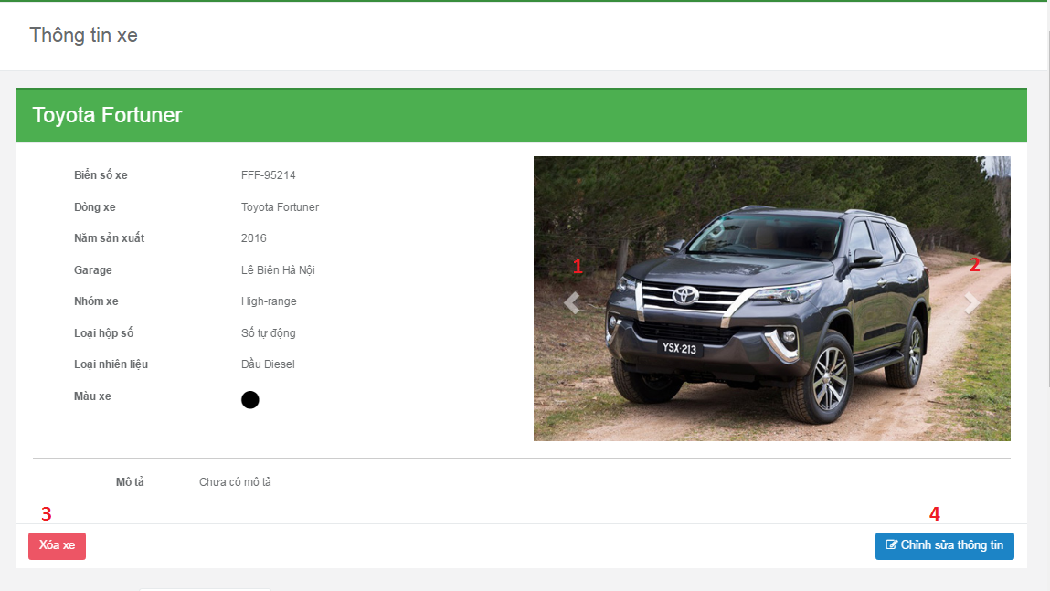

**Buttons/Hyperlinks**

|  |  |  |  |  |
| --- | --- | --- | --- | --- |
| No | Function | Description | Validation | Outcome |
| 1 | leftArrow | Clicks to show image on the left side | N/A | Show image on the left side |
| 2 | rightArrow | Clicks to show image on the right side | N/A | Show image on the right side |
| 3 | deleteVehicle | Clicks to delete vehicle | N/A | Show delete vehicle confirm popup |
| 4 | editVehicleInfor | Clicks to edit vehicle information | N/A | Show edit field top edit. |

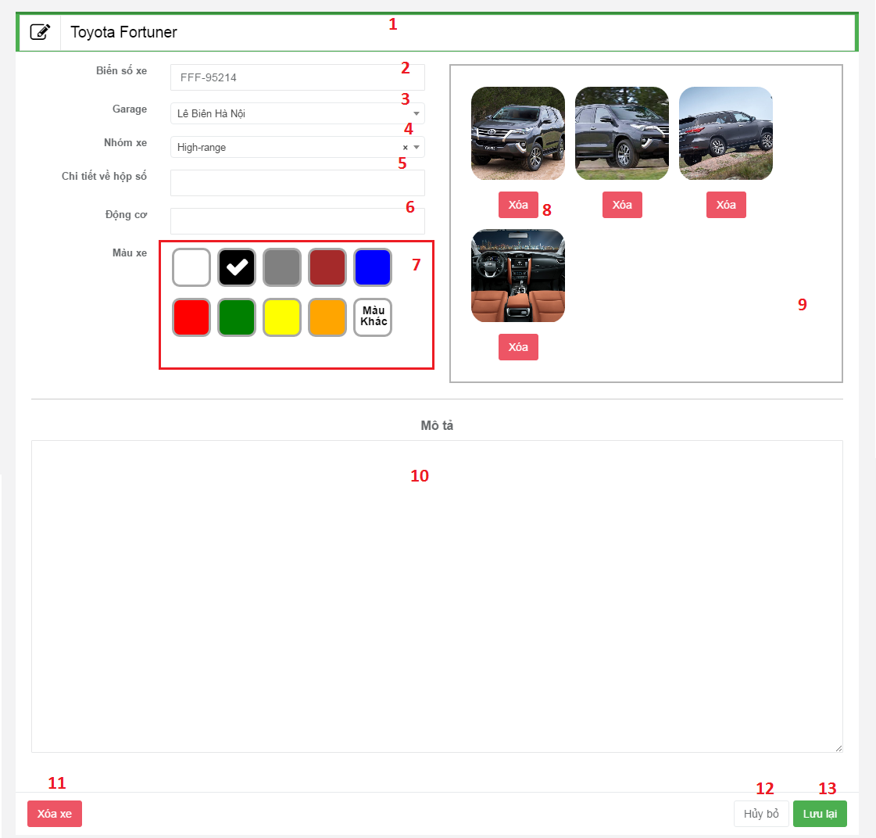

**Fields**

|  |  |  |  |  |  |  |
| --- | --- | --- | --- | --- | --- | --- |
| No | Field Name | Description | Read Only | Mandatory | Control Type | Data Type |
| 1 | vehicleNameField | Input vehicle name | No | No | Textbox | String |
| 2 | licenseNumber | Input license number | No | No | Textbox | String |
| 3 | garageList | Choose garage that vehicle belong | Yes | No | Dropdownlist | String |
| 4 | vehicleGroupList | Choose vehicle group that vehicle belong | Yes | No | Dropdownlist | String |
| 5 | transitionTypeDetail | Input more information of the vehicle transition type detail | No | No | Richtextbox | String |
| 6 | Engine | Input engine of the vehicle | No | No | Textbox | String |
| 7 | Color | Choose vehicle’s color | Yes | No | Radio button | String |
| 10 | Description | Input description of the vehicle | Yes | No | Richtextbox | String |

**Buttons/Hyperlinks**

|  |  |  |  |  |
| --- | --- | --- | --- | --- |
| No | Function | Description | Validation | Outcome |
| 8 | deleteImage | Delete vehicle’s image | Can’t delete when current pictures less than 4 | Show the remain image |
| 9 | uploadImage | Choose new images to upload | Can’t upload more than 10 pictures | Show explorer where user can choose image from their computer |
| 11 | deleteVehicle | Clicks to delete this vehicle | N/A | Show delete vehicle confirm popup |
| 12 | cancelButton | Clicks to cancel edit view | N/A | Show back vehicle information |
| 13 | saveButton | Clicks to save the change user make to the vehicle | Validate all require field | Refresh current page to show new information |

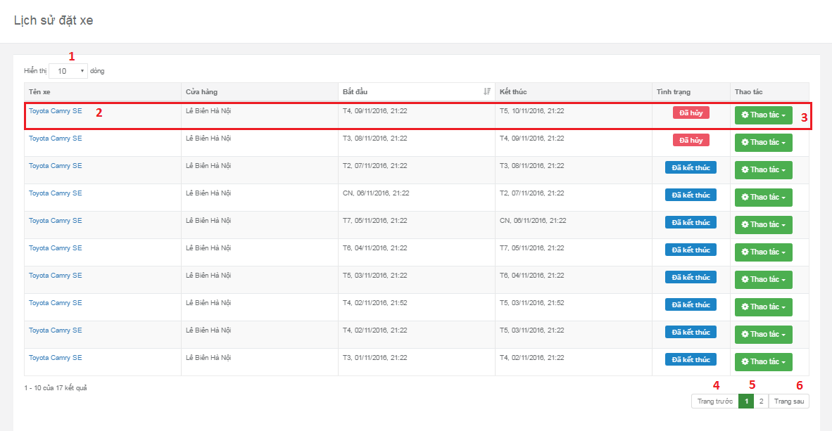

**Fields**

|  |  |  |  |  |  |  |
| --- | --- | --- | --- | --- | --- | --- |
| No | Field Name | Description | Read Only | Mandatory | Control Type | Data Type |
| 1 | numberOfDataShow | List of how many result user want to see in table | No | No | Dropdownlist | Integer |

**Buttons/Hyperlinks**

|  |  |  |  |  |
| --- | --- | --- | --- | --- |
| No | Function | Description | Validation | Outcome |
| 2 | linkToVehicleDetail | Go to vehicle detail page | N/A | Go to vehicle detail page |
| 3 | showOptionUserCanDoToVehicle | Show option user can choose: detail information, rating, cancel booking | User can’t rate rated vehicle or cancel book ended booking | Show option user can choose: detail information, rating, cancel booking |
| 4 | previousButton | Show previous data page | N/A | Show previous data page |
| 5 | numberPage | Clicks to show data in choose page | N/A | Show data in choose page |
| 6 | nextButton | Show next page | N/A | Show next data page |

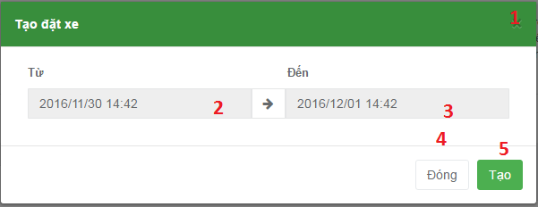

**Fields**

|  |  |  |  |  |  |  |
| --- | --- | --- | --- | --- | --- | --- |
| No | Field Name | Description | Read Only | Mandatory | Control Type | Data Type |
| 2 | startTime | Choose own booking start rent time | Yes | No | DateTimePicker | String |
| 3 | endTime | Choose own booking end rent time | Yes | No | DateTimePicker | String |

**Buttons/Hyperlinks**

|  |  |  |  |  |
| --- | --- | --- | --- | --- |
| No | Function | Description | Validation | Outcome |
| 1 | closePopup | Close popup and back to vehicle’s detail page | N/A | Back to vehicle’s detail page |
| 4 | closeButton | Close popup and back to vehicle’s detail page | N/A | Back to vehicle’s detail page |
| 5 | createButton | Accept create booking | N/A | Show alert created booking |

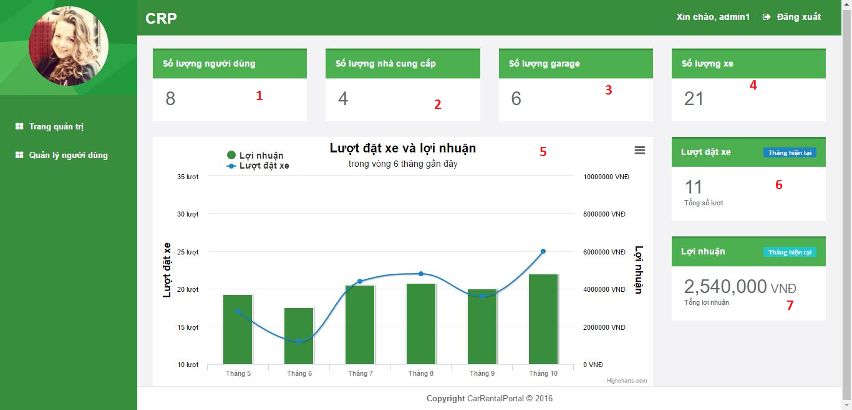

**Fields**

|  |  |  |  |  |  |  |
| --- | --- | --- | --- | --- | --- | --- |
| No | Field Name | Description | Read Only | Mandatory | Control Type | Data Type |
| 1 | numberOfUser | Show number of user | Yes | No | Textbox | String |
| 2 | numberOfProvider | Show number of provider | Yes | No | Textbox | String |
| 3 | numberOfGarage | Show number of garage | Yes | No | Textbox | String |
| 4 | numberOfVehicle | Show number of vehicle | Yes | No | Textbox | String |
| 5 | numberOfBookingAndProfit | Show graph display number of booking and profit | Yes | No | Graph | String |
| 6 | numberOfBooking | Show number of booking | Yes | No | Textbox | String |
| 7 | profit | Show number of profit | Yes | No | Textbox | String |

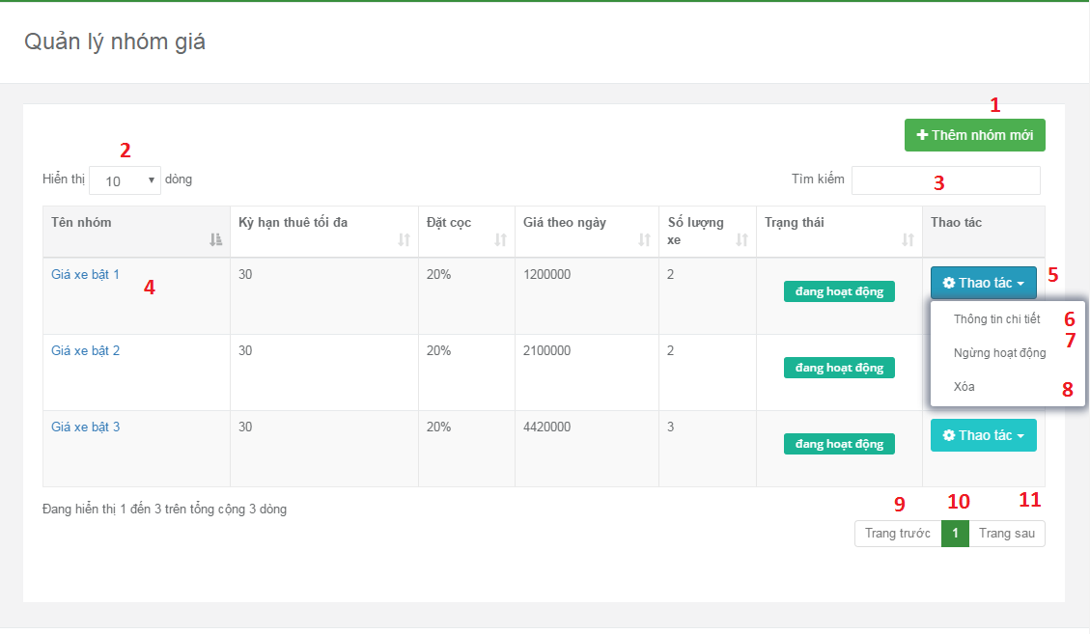

**Fields**

|  |  |  |  |  |  |  |
| --- | --- | --- | --- | --- | --- | --- |
| No | Field Name | Description | Read Only | Mandatory | Control Type | Data Type |
| 2 | numberOfDataShow | List of how many result user want to see in table | No | No | Dropdownlist | Integer |
| 5 | showOptionUserCanDo | List things provider can do to that vehicle group | No | No | Dropdownlist | Integer |

**Buttons/Hyperlinks**

|  |  |  |  |  |
| --- | --- | --- | --- | --- |
| No | Function | Description | Validation | Outcome |
| 1 | createNewVehicleGroup | Create new vehicle group | N/A | Create vehicle group popup |
| 4 | linkToVehicleGroupDetail | Go to vehicle group detail page | N/A | Go to vehicle group detail page |
| 6 | showVehicleGroupDetail | Go to vehicle group detail page | N/A | Go to vehicle group detail page |
| 7 | deActiveVehicleGroup | Deactive vehice group | N/A | Deactive vehice group |
| 8 | deleteVehicleGroup | Delete vehicle group | N/A | Delete vehicle group |
| 9 | previousButton | Show previous data page | N/A | Show previous data page |
| 10 | numberPage | Clicks to show data in choose page | N/A | Show data in choose page |
| 11 | nextButton | Show next page | N/A | Show next data page |